Chris Hansen
Senior Advisor, Janys Analytics;
Candidate for the Colorado House of Representatives, District 6

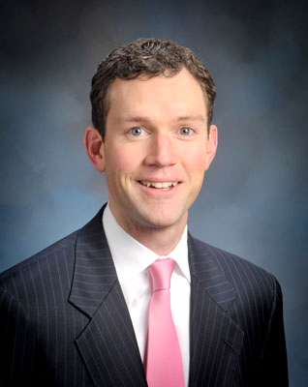
Chris Hansen specializes in energy sector economics and data analytics, with more than 15 years of experience in the global energy industry. His current role at Janys Analytics is focused on the development and commercialization of social media-derived products. He is also a candidate for the Colorado House of Representatives, District 6, representing the east-central neighborhoods of Denver.

Previously, as Senior Director at IHS he led a global portfolio of energy events and partnerships, including programs and communities for CERAWeek, a 3000-person executive event focused on energy markets. In addition, he directed a social media analytics development team with a suite of products across several industries. Dr. Hansen was based in Dubai in 2008-09, where he managed a comprehensive review of the Emirate’s energy sector. He is a co-creator of the OptGen analysis, IHS CERA’s unique tool for applying financial portfolio techniques to power generation.

Before joining IHS, Dr. Hansen was a Research Fellow at the Oxford Institute for Energy Studies, where he analyzed electricity and gas sector reform in India, and published several papers in professional journals on energy sector economics and policy analysis. Dr. Hansen holds a BSc in Nuclear Engineering from Kansas State University; a Graduate Diploma of Civil Engineering from the University of the Witwatersrand, South Africa; a Master of Science in Technology Policy from MIT; and a PhD in Economic Geography from Oxford University.

Hansen’s community involvement includes serving on the Denver Metro Chamber Leadership Foundation Board as Secretary, the Co-Chair of the Colorado Energy Coalition, the Central City Opera Board Executive Committee, Denver Kids Mentoring Program, and the UC-Denver Business School Advisory Board. In 2012, he was selected as a Marshall Memorial Fellow by the German Marshall Fund.

George Pond
Senior Vice President for Design & Campus Management
Denver Zoo

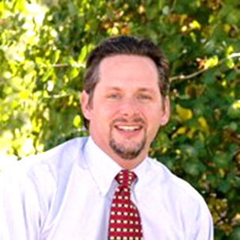
George Pond is the Senior Vice President for Design and Campus Management at Denver Zoo; he is responsible for the development and execution of the zoo's facility master plan, including the design and construction of new exhibits and facility improvements. George oversees the Facilities Group which is responsible for facilities planning and design, management of grounds and horticulture, maintenance of all existing facilities, and the zoo’s safety and sustainability initiatives. George has two Masters Degrees in Architecture and in Landscape Architecture, both from the University of Colorado at Denver, and a Bachelor of Arts in English from Kenyon College. George has been with the zoo for fifteen years and during that time has also served on faculty at the College of Architecture and Planning at the University of Colorado at Denver as a lecturer and senior instructor in landscape architecture, and is currently an elected City Councilman and Mayor Pro-Tem in Wheat Ridge, Colorado.

Jennifer Hale
Director of Safety & Sustainability
Denver Zoo
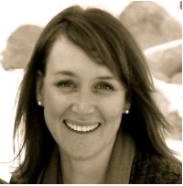
Jennifer is the Director of Safety and Sustainability for Denver Zoo, located in Denver, Colorado. In this role, Jennifer manages a team that oversees the management of Denver Zoo’s environmental, health and safety programs through a 3rd party certified Sustainable Management System (SMS). The SMS is a framework that supports continual improvement of Denver Zoo’s operations and the impacts our organization has on the environment or human health and safety.

In addition to her role at Denver Zoo, Jennifer was recently the Chair of the AZA Green Scientific Advisory Group (GSAG). She is proud of all the work GSAG has accomplished over the years and the opportunity to collaborate with other AZA institutions in developing guidelines to support AZA members in the creation of sustainability plans that work best for their organization.

Jeremiah Cummins
Browse Specialist
Denver Zoo
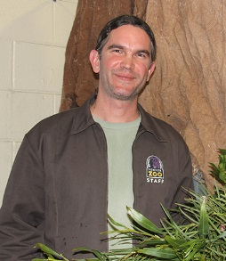
Jeremiah has worked in the zoo field since 2006, the majority of that time as an animal keeper. When Denver Zoo created the Browse Specialist position in 2014, he joined the Horticulture Department in that capacity. Now he grows and harvests trees to provide plant material to the many leaf eating animals in the collection.

Tom Cech
Director, One World One Water Center for Urban Water Education & Stewardship
MSU Denver
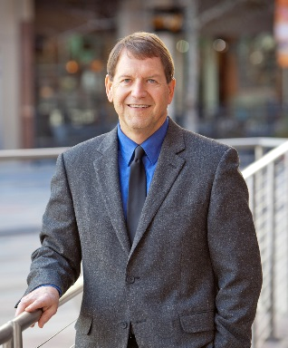
Tom Cech was born and raised on a farm near Clarkson, Nebraska, graduated from Kearney State College with a Bachelor of Science Degree in Math Education, and later received a Masters Degree in Community and Regional Planning from the University of Nebraska – Lincoln. He was Executive Director of the Central Colorado Water Conservancy District in Greeley, taught water undergraduate and graduate level water resources courses at the University of Northern Colorado and Colorado State University, and is now the Director of the One World One Water (OWOW) Center for Urban Water Education and Stewardship at Metropolitan State University of Denver.

Pete Maysmith
Executive Director
Conservation Colorado
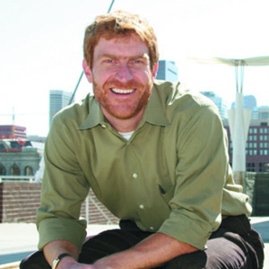
Pete Maysmith is the Executive Director of Conservation Colorado, the largest state-based environmental group in Colorado. Pete led the formation of Conservation Colorado in 2013 by merging two of the state’s leading environmental groups. Since he became Director in 2009, the group has seen a sevenfold increase in budget and has grown to over 8,000 members and 37 staff.

Pete received his degree in Public Policy from Duke University in 1991 and graduated with honors from the University of Denver School of Law in 2008. Over the course of his 24 year career in advocacy and politics, Pete has run state organizations and served on the senior staff of national organizations. In those capacities he has lobbied, organized, run campaigns, raised millions of dollars, and hired and trained dozens of exceptional staff. After working for a number of years in Washington D.C., Pete moved back to his home state of Colorado in 1996. He lives in Denver with his wife and two red haired daughters. He loves to run, cook, and read whenever he can find the time.

